

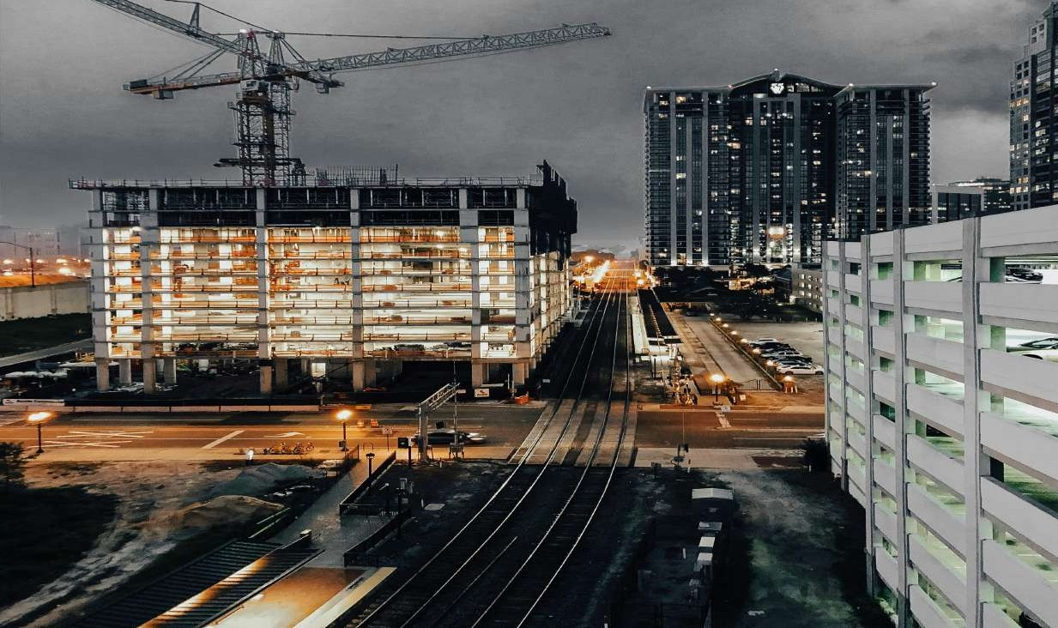CONSTRUCTION PROJECT MANAGEMENT CONSTRUCTION PROJECT MANAGEMENT
“A fast growing construction
company bringing experience and creativeness”
C O M P A N Y
P R O F I L E

BUILDING CONSTRUCTION

CIVIL ENGINEERING WORKS ARCHITECTURAL WORKS

² General Contractors


COMPANY OVERVIEW
3
INTERPAC CONSTRUCTION LIMITED
General Contractors

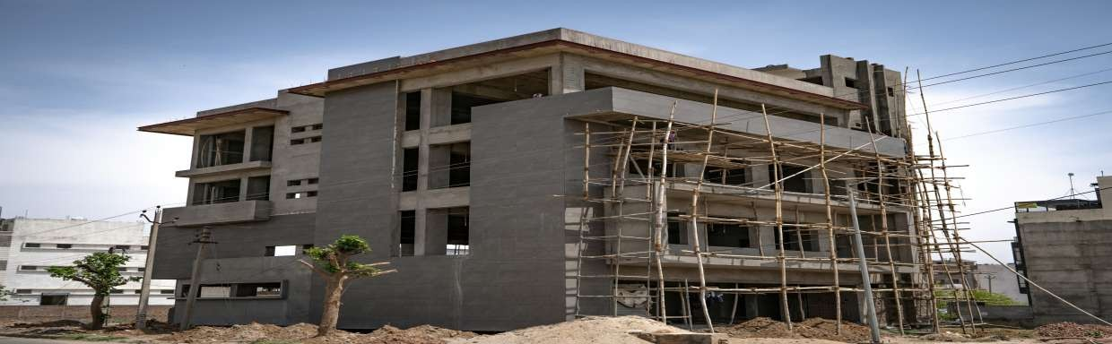INTERPAC CONSTRUCTION LIMITED is led by a Director who is fully experienced

Company
Overview
in various fields of specialisation, with vast experience in the construction Industry.

INTERPAC CONSTRUCTION LIMITED was incorporated in the year 2016 in Kenya under the Company Act Laws of Kenya.

REGISTRATION DETAILS OF THE COMPANY
Certificate of Incorporation Pin Certificate
Trading License
Tax Compliance Certificate NCA Registration Certificate
NATIONAL CONSTRUCTION AUTHORITY (NCA)

CONTACTS DETAILS: P.O. Box 108 - 60600,
Maua, Kenya

Tel: +254 728 206 904

Building your future with passion
OUR PROFILE

Who we are?

“We at INTEPAC CONSTRUCTION
LIMITED have set our services diversification as well as geographic broadening our areas of business operations to fulfil firms missionin Kenya.

INTERPAC CONSTRUCTION LIMITED is a
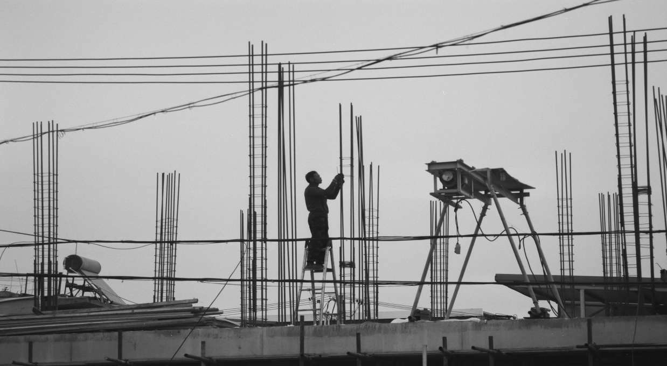Private Limited Company, which was incorporated in the year 2016, in Kenya under the Company

INTERPAC CONSTRICTION LIMITED
Act Laws of kenya,

Since Inception, the firm has been providing Building Construction and Civil Engineering works to both Private Companies and Government Institutions, with a clear vision of delivering comprehensive range of quality services.

We are versatile company with a reputation for outstanding quality workmanship, which has broadened our focus with a diversified new fields of specialisation, modern technologies and we have maintained continued success by looking forward in offering best services to our clients.

(ICL) has grown rapidly from the humble beginning since its Initiation and has now becoming one of Kenya’s premier Building construction and Civil Engineering specialists, operating across the Country in full sector domain and aiming to open other areas of operation across the Country.



INTERPAC CONSTRUCTION
5 LIMITED
General Contractors

“We have became known for our ability to satisfy our customers in quality and the ability to safely meet projects within time frame and with the allocated resources. We have Coupled our goals under the founding principle that gives our clients confidence as evidenced by a long list of successful projects.”
We have pride in our supported expertise across our modulated Programme and technologies, which would boasts and ensure that internal systems and the Company’s supply chain is set-up with the end result for Satisfying our clients needs. We have warehouse facility for storing heavy equipments, various stocks of construction materials, steel fabrication workshop equipped with up-to-date machines and equipments.

Our staffs is professionally trained and maintains a very high of discipline and professionalism in all their undertakings to maintain our exemplary record in service delivery and good turnaround time, a feature we pride in to keep our customers satisfied. Our aim is to work closely with our clients to build trust and mutual respect thus ensuring continued business development milestones.

INTERPAC CONSTRUCTION
LIMITED has ventured into Understanding the Current markets trends in the Building construction and Civil Engineering works Industry, as well as appreciating the needs of our clients, which has madeus to reinforces our search for value and cost effective to our clients.

We have highly skilful project teams that can deliver superior knowledge about the latest trends in construction through in-depth reporting and exploration, of new ideas to foster business growth.We have notable proven Fast track record to deliver
end-to-end in both construction fields and property solutions across a broad range of sectors.


US

ABOUT
About
Us

INTERPAC CONSTRUCTION LIMITED
6
General Contractors

About US

Our Company philosophy has evolved from our aim to earn the trust and confidence of our clients through close association and integrated planning in the pre and post contract phases. Our expertise covers Building and Civil Engineering discipline which when combined with our structural, mechanical, civil and electrical knowledge and experience, enables us to offer competitive solutions to clients’ requirements.
INTERPAC CONSTRUCTION LIMITED, has undertaken all kinds of construction
worksranging from small buildings to large and complex developments, within the entire
country for leading private developers, Organizations and Governmental Institutions.

The works undertaken by (Interpac Construction Limited) includes-:
- Specialised Commercial Buildings
- Office Blocks
- Industrial Projects,
- Residential Buildings Etc.
- Educational Institutes
- Healthcare Buildings
- Office Fit Outs and Interior Works
- Architectural Works, Civil Works and Infrastructure Works

We have adequate equipment, construction materials, experience and capacity to complete project on time and on budget. Benefit from our experienced field supervision, skilled labor force, and quality materials, quality workmanship gained through the past work experience. Our Construction Company is composed of various construction professionals who each in their various capacities and departments add their expertise and experience to the overall functioning and operations of the larger company.
INTERPAC CONSTRUCTION LIMITED, Being Strongly and diversified across
market segments, the Company has delivered seamless solutions to customers in fiels of automotive, steel, refining, petrochemical, food processing, marine, manufacturing, power generation etc.

INTERPAC CONSTRUCTION
7 LIMITED
General Contractors



VISION

"Our mission is to design, build, and deliver high-quality, innovative construction projects that
meet the evolving needs of our clients and communities."

MISSION

"To be a leader in the construction industry, recognized for our innovation, sustainability, and commitment to excellence. We envision a future where our work not only meets the needs of today but also anticipates the demands of tomorrow, contributing to a more resilient and connected world."

INTERPAC CONSTRUCTION 8
LIMITED
General Contractors

Our Core Values
As a company, and as individuals, we uphold personal excellence, honesty and openness, progressive self-development and mutual respect.
We take pride in seeing the successful end of each challenge and hold ourselves accountable to our customers and employees by honouring our commitments, providing results and striving for the highest quality in the end product

Safety
We create a working environment that promotes enhanced safe performance.

Quality
We always strive for excellence in the services we provide and in the results we produce for our clients beyond their expectations.

Integrity
We are committed to the highest ethical Standard & Regulation

Creativity
We believe in looking at challenges and opportunities from new angles and in exercising our curiosity, innovation, exploration, experiences, good practices & above all adhere to all regulations which will make our organization run smoothly.

Accountability
We take responsibility for all of our decisions and actions.

Teamwork
We work together to succeed. Involvement of people at all level are the essence of an organization and their fully involvement enables their abilities to be used for benefits.

Passion
We deliver superior results because we care deeply about what we do. Quality Products & On time Delivery. Measure and improve company’s performance through the development of Key Performance Indicator ( KPI’S )

Co-Ordination
The multi-discipline capabilities within the company give clients the benefit of total co-ordination of all phases on projects which require a number of specialties without necessarily outsourcing for specialist to handle sections of the projects.

Collaboration
In addition to our professional and commercial services, we have arrangements with other reliable organizations for the collaboration on any type and size of project where this could become necessary.

INTERPAC CONSTRUCTION
9 LIMITED
General Contractors

Our Business Focus

INTERPAC CONSTRUCTION LIMITED, continued
progressand un wavering use of Modern Technologies and focus tonewly research in the market trends has enabled us to carry out Building Construction and Civil Engineering services,

to ourcustomers
at fair
and
within
the
market

competitive prices.
Our skilled and reliable team are committed to bringing out the best in each other, and working in harmony with our team consultants. We run our projects smoothly, professionally and with full supervision.
We prioritise clear and effective communication with our clients, enabling us to establish strong working relationships and produce the best possible outcomes on every project.
Our goal is to exceed our client’s expectations at all times, by maintaining the highest level of professionalism, integrity, honesty and fairness in our relationships with our suppliers, subcontractors,partners, professional associates and customers.
We are dedicated in adding value to our customers through innovation, foresight, integrity, and aggressive performance and to serve with character and purpose.
We always take the first priority to ensure the satisfaction of our company staff and employees by awarding with good remuneration, better living conditions and making the company working environment conducive for unleashing their efficiency and potential the employer, employee relationship as mutually beneficial.

(ICL) is committed to delivering high-quality, cost-effective projects by employing and supporting motivated, flexible, and focused individuals.
We will strive to implement long-term relationships with our clients based on quality, health and safety, timely service and an anticipation of their needs.


INTERPAC CONSTRUCTION LIMITED
General Contractors

1010

Project Management

PROJECT TEAM
INTERPAC CONSTRUCTION LIMITED , has experienced management teams which provides detailed attention throughout the project, fromdesign, review, and implementation.
Our qualified skilled personnel are trained to carry out projects and data control processes, assigned to project types in which they have specific experience and expertise.
We have extensive use of expedition software a multi-user, multi-project, client/server database. Implemented for each project, controlling document and information. Organization of daily reports, meetings minutes submittals, costs reporting. Insurance and project team contact information.

PROJECT CONTROL AND BUDGET ESTIMATE
We closely manage Projects specific logistics planning for coordination meetings, inventory management and site utilization for construction sequence, staging areas, site offices and security options. Our team is experienced to carry out, Planning, communication, documentation required to maximize work flow, project execution and make materials delivery.
The team Leader would clarify the objective and develop a scope of work
with quantified, realistic budgets and schedules.
Proper document control, submittal review, project close outs, as-built, start up and commissioning. Pre-qualification and selection of trades assuring that quality craftsmanship and materials comply with technical specifications.

DOCUMENT CONTROL
INTERPAC CONSTRUCTION LIMITED , Research & Development Department and associated processes and procedures will as appropriate be utilized to develop and implement the
following controls:

  - Receiving Documents and Workflow Tracking
  - Generating Documents
  - Document Security, Retrieval and Disposal
  - Generating Internal Document
  - Information Technology Help Desk

INTERPAC CONSTRUCTION
11 LIMITED
General Contractors

Site Administration
We are customed and able to provide a wide variety of administrative services to the project, including the maintenance of personnel files, handling and storage of consumable materials related to administrative services. Key activities and controls to be established are:
- Transfer of employees between projects
- Personnel evaluations in liaison with Human Resources Department

PROJECT REALIZATION
To achieve our project goal, INTERPAC CONSTRUCTION LIMITED,
has the ability to assign key project team members who shall plan and developprocesses and associated supporting documentation that will encompass asystems management approach. Our organization shall implement definedmethodologies and monitor their effectiveness and efficiency in order toprovide control of the quality of project activities .

SHOP DRAWINGS PRODUCTION
Project management coordination role shall be established by the Engineering Department and key responsibilities, authorities and interfaces (including those with the Client, Sub-contractors and/or Suppliers) shall be clearly defined. Verification reviews shall be in accordance with the standard construction and civil engineering criteria.

PURCHASING CONTROL
INTERPAC CONSTRUCTION LIMITED, aims to establish sound supplier andsubcontractor relations in order to develop a mutually beneficial relationshipthat improves the ability of all parties to create value to a project. Assessmentand recording of new and existing suppliers / subcontractor’s capabilities andperformance shall be implemented by the Company Supply Chain. Effectivecontrols shall be implemented to ensure that the interfaces between suppliers/subcontractors, project management and the Client are clearly defined whilstdelivering products or services to the project that meet with the specificationrequirements.

MONITORING CONTROL
We have established appropriate methods which shall be used on site for identifying and recording the identification, and traceability status of materials, products, services throughout all stages of the project as defined in the respective processes for Procurement and Quality Management.

12

Preservation

Throughout construction operations, appropriate methods of identification, handling, packaging, storage and protection shall be employed to ensure that all goods, materials, product and site provisions are properly protected from damage, deterioration and loss.

This is also important with regards to property belonging to the Client, which may include intellectual property (e.g. designs, drawings) and project site itself.

MONITORING CONTROL AND MEASUREMENT DEVICES
INTERPAC CONSTRUCTION LIMITED, has developed and
established a procedure that details and records the preventive actions taken to eliminate the cause of potential
non-conformity in order to prevent their occurrence.

Preventive action implemented will be appropriate to the impact of the potential problem encountered.

The goals set by INTERPAC CONSTRUCTION LIMITED,
executive management relevant to the success of the Project shall be effectively communicated throughout the organization and such responsibilities, authorities etc shall be defined and performance monitored on an ongoing basis.

Appropriate communication channels shall be established within
the project organization including interfaces with external parties.

13

Environmental Management Policy Statement

INTERPAC CONSTRUCTION LIMITED, closely observes andworks with employees, clients, suppliers and other relatedorganizations to upgrade our enduring operational

strategiesand standards.
working
procedures to
best
practice

INTERPAC CONSTRUCTION LIMITED, prime target
operationally is to eliminate our negative environment impact by whatever possible minimizing the wastage, and prevent the usage of environmentally unfriendly products, while endeavoring to maximize our positive environmental impact and better living conditions.

We will keep up and maintain the environment around us clean and safe, and regularly monitor, raise alarm and respond to any hazardous environmental situation observed.

We will ensures that each activities will always comply with the Government’s Environmental Policy, follow and maintain them in all our administrative, operational, logistics and site areas of our projects.

Our firm affirms that all managerial and supervisory staff are accountable for environmental performance in their area of responsibility

INTERPAC CONSTRUCTION LIMITED
14
General Contractors

Health And Safety Policy Statement
INTERPAC CONSTRUCTION LIMITED , firmly believes in the significance of health and safe working practices of our employees, as it forms thefundamental part of the effectiveness and efficiency of our management.Furthermore, as an organization and the employer, we do acknowledgeour commitment, so far as is reasonably, in ensuring for the healthand safety of our employees, public health and not to endanger our environment.
Our organization, recognizes that in our duties and responsibilities to our employees, the foremost requirement is providing and maintaining hygienic conditions, healthy environment and safe work practices in addition,

INTERPAC CONSTRUCTION LIMITED , also comprehends
the relationship between efficiency and safety in terms of cost control, losses,ill health and the lost time injuries due to accidents .
Every managerial and supervisory staff shall apply the organizations safety policy and all legislative provisions in their areas of control and execute all reasonably practicable measures to provide a healthy and safe working environment.
We also consider that every employee in our organization has an individual responsibility ensuring strict adherence to company’s and all legislative safety requirements and it is their obligation working with the management in maintaining good standards of Health & Safety.

Furthermore,

INTERPAC CONSTRUCTION LIMITED
, will


conduct induction program and provide training and instruction to enable employees to carry out their duties in a safe and efficient manner, andas well make all necessary devices and protective equipment issuedand supervise its use as required and will involve staff on all discussions toimprove Health & Safety.



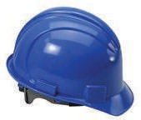We have a professional safety precaution auditors who monitor our projects to continue improve on Health & Safety.


INTERPAC CONSTRUCTION
15 LIMITED
General Contractors

Our Quality Policy / Project Quality Plan

Project Quality Plan
INTERPAC CONSTRUCTION LIMITED, quality plan is developed a nd approved during the project planning phase to confirm major deliverables/milestone acceptance criteria and manage approved project processes.

Quality Plan Processes/ Quality Assurance
We focus on Quality assurance activities and the processes being used to manage and deliver the solution to evaluate overall project performance on a regular basis.

Quality Control
Our Quality control activities are performed continually to verify that project management and project deliverables are of high quality and meet quality standards. Quality assurance also helps uncover causes of unsatisfactory results and establish lessons learned to avoid similar issues in this project.
The Quality Control Manager reviews the testing requirements to ensure that the planned test is in accordance with the design documents: i.e. plans, specifications, shop drawings and/or other documents. Instruments used for testing are well calibrated in accordance with established testing procedures. All materials are tested, approved and maintained throughout the project
Technicians performing tests will provide copies of test certificates and their field notes and report to the Quality Control Manager. The Quality Control Manager witnesses all required tests detailed in the design documents (plans, specifications, materials, etc.).
Test reports, when completed, are attached to the Contractor’s Quality
Control Report

Project Deliverables and Processes Acceptance Criteria
INTERPAC CONSTRUCTION LIMITED, Project team members and key stakeholders agree at the project planning stage on formal project processes and major deliverable acceptance criteria that will be used to evaluate finaldeliverable results before the results are formally approved.

Project Overview
We have tracking tools which describes the background and context for the project to provide its justification. Identifies the business value of the proposed deliverables.

Quality Standards
Our capability gives us an account of how the project will satisfy the quality standards.

Quality Tools and equipment
We have check List of all quality-related tools that the project will employ, how the tools will be used, and who will be responsible for managing and reporting from these tools.

INTERPAC CONSTRUCTION 16
LIMITED
General Contractors


Green Technology
We have embraced Sustainability and low-impact processes which are the foundation of green construction. Wise use of materials is part of every stage in the life cycle of the building from sourcing materials and construction to
operations.

Green construction includes:
    - Specialized designs and materials with limited environmental
impact
    - Processes that are environmentally responsible
    - Focus on conserving as much energy and water as possible
    - Use of recycled or renewable materials
    - Resource efficient processes

Saving our envioronment is the only motivation propelling the green building trend, Durability, savings, and efficiency are also compelling reasons “green” is big business. We have followed international certification program with rating systems for the green design, construction, and operation of buildings, homes, and neighborhoods.

INTERPAC CONSTRUCTION
- LIMITED
General Contractors

Project Categories

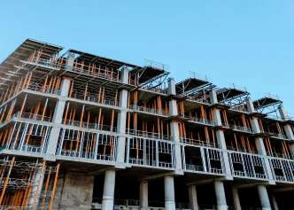
Office Developments


Commercial Developments

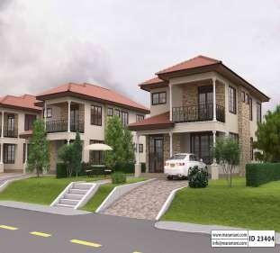
Residential Development


Institutional Development

INTERPAC CONSTRUCTION
- LIMITED
General Contractors

CERTIFICATE OF INCORPORATION

